Epsom & Ewell
13
v
Godalming Town
Saturday, 1st December 2018 – 3.00 p.m.
Good afternoon! We welcome the players, supporters and officials of Godalming Town to High Road for an important League match.

Our opponents had an equally bad season to ourselves in 2017/18 with relegation being something that was not on either team’s radar as both clubs were generally expected to be contenders at the business end of the table. For our opponents it was their second straight relegation and in my opinion they were very harshly displaced by Raynes Park Vale who only finished fifth in our current division last term.

We both won our away fixtures against each other last season. They won here easily 3-0 in November of last year while we returned the favour with a come from behind 2-1 win at Wey Court in January.

We were last here just four days ago when we hosted Dorking Wanderers Reserves and the performance was one of our best of the season as we performed for the full 90 minutes with a high tempo and in the end our 3-0 win probably didn’t cover the dominance of our performance against a team it should be remembered that beat us 5-3 back in September.

Going forward, we are back here next Saturday as we host league leaders Bedfont & Feltham and then currently have a two week break before journeying to Woking F.C. for our return League match with Sheerwater.

Unfortunately I must advise that in recent weeks, our Chairman’s wife Maggie Beddoe has suffered a fall and has been in hospital as a result. The club sends her our best wishes for a full recovery and hope to see her back on her feet as soon as possible.

Finally, we will be holding a minute’s silence before the match today as a mark of respect for the Combined Counties League President Ken Huckle. Ken served many roles for the League and we will be recognising that here.

Enjoy the game!

Rich

You can follow us on Facebook: www.facebook.com/epsomandewellfc
Twitter: @EEFCOfficial Instagram at: www.instagram.com/epsomandewellfc
and Youtube at: www.youtube.com/channel/UCtLrpS0x5OaYUACRT34_zng

Cover photo by Gemma Jarman

Adam Heagney scores our equaliser at Eversley & California last Saturday

Cherry Red Records Combined Counties League
Division One Table 2018/19
inc Tuesday 27th November 2018 | P | W | D | L | F | A | Pts | GD | H | A
Bedfont & Feltham | 15 | 11 | 3 | 1 | 53 | 13 | 36 | +40 | 8/12 | 13/4
Frimley Green | 17 | 10 | 5 | 2 | 33 | 22 | 35 | +11 | 3-0 | 23/2
Sheerwater | 16 | 10 | 3 | 3 | 37 | 23 | 33 | +14 | 2-3 | 22/12
Farnham Town | 15 | 9 | 4 | 2 | 33 | 13 | 31 | +20 | 2/2 | 1-4
Epsom & Ewell | 17 | 10 | 1 | 6 | 40 | 27 | 31 | +13 | X | X
Tooting Bec | 16 | 9 | 2 | 5 | 32 | 22 | 29 | +10 | 3-1 | 30/3
Dorking Wanderers Res | 18 | 8 | 3 | 7 | 40 | 37 | 27 | +3 | 3-0 | 3-5
Sandhurst Town | 15 | 8 | 3 | 4 | 24 | 25 | 27 | -1 | 20/4 | 2-0
Ash United | 16 | 7 | 4 | 5 | 42 | 35 | 25 | +7 | 12/1 | 2-1
British Airways | 17 | 7 | 3 | 7 | 39 | 38 | 24 | +1 | 16/2 | 2-3
Chessington & Hook Utd | 15 | 7 | 2 | 6 | 28 | 28 | 23 | 0 | 1-2 | 4-1
Eversley & California | 14 | 5 | 1 | 8 | 31 | 36 | 16 | -5 | 29/12 | 1-2
Bagshot | 17 | 4 | 2 | 11 | 17 | 56 | 14 | -39 | 19/1 | 3-0
Godalming Town | 14 | 3 | 3 | 8 | 17 | 30 | 12 | -13 | 1/12 | 26/1
Kensington Borough | 16 | 3 | 3 | 10 | 24 | 42 | 12 | -18 | 1-1 | 9/3
FC Deportivo Galicia | 15 | 2 | 3 | 10 | 22 | 29 | 9 | -7 | 12/3 | 3-0
Fleet Spurs | 15 | 3 | 0 | 12 | 25 | 43 | 9 | -18 | 6/4 | 3-2
Cove | 14 | 2 | 1 | 11 | 17 | 35 | 7 | -18 | 3-2 | 5/1

AC London (removed) | 15 | 9 | 2 | 4 | 36 | 25 | 29 | +11 | - | 6-0

Lucky Day? – 1st December
Played 14 - Won 2 Drawn 3 Lost 9 - For 19 Against 38 - PPG 0.64 - Very Poor
Our Club record against Godalming Town
Played 3 - Won 2 Drawn 0 Lost 1 - For 4 Against 5 - PPG 2.00 - Very Good
Godalming Town‘s last visit
Tuesday 21st November - Lost 0-3 - Combined Counties League

First Eleven Appearances 2018/19 - (max 26)
Name | Debut | 2018/19 |  |  |  | Career Totals
 |  | App | Sub | Tot | Goals | App | Sub | Tot | Goals
BENNETT Bobby | 12/08/2018 | 20 | 0 | 20 | 13 | 20 | 0 | 20 | 13
BETANCOURT Steve | 18/08/2018 | 20 | 1 | 21 | 1 | 20 | 1 | 21 | 1
BORRETT Ricky | 04/08/2018 | 9 | 0 | 9 | 0 | 9 | 0 | 9 | 0
CAMPBELL Kieran* | 29/09/2012 | 7 | 3 | 10 | 2 | 59 | 3 | 62 | 2
CAMPBELL Theo | 28/08/2018 | 2 | 9 | 11 | 1 | 2 | 9 | 11 | 1
CAULCRICK Joshua | 17/02/2018 | 0 | 3 | 3 | 0 | 0 | 4 | 4 | 0
CONNELLY Lloyd | 14/10/2017 | 26 | 0 | 26 | 4 | 56 | 4 | 60 | 6
DOBRAJ Endrit* | 18/11/2017 | 5 | 2 | 7 | 1 | 24 | 6 | 30 | 1
DYSON Ben* | 12/08/2017 | 0 | 1 | 1 | 0 | 28 | 14 | 42 | 2
ELGAR Luke | 04/08/2018 | 7 | 3 | 10 | 1 | 7 | 3 | 10 | 1
ELGAR Scott | 12/08/2018 | 4 | 9 | 13 | 0 | 4 | 9 | 13 | 0
GAFFNEY Luke * | 16/08/2014 | 2 | 2 | 4 | 0 | 12 | 3 | 15 | 0
GAYLE Roy | 06/11/2018 | 3 | 0 | 3 | 0 | 3 | 0 | 3 | 0
GILL George | 28/08/2018 | 2 | 0 | 2 | 0 | 2 | 0 | 2 | 0
GRIFFIN Reisse | 08/08/2015 | 15 | 0 | 15 | 2 | 119 | 13 | 132 | 10
HEAGNEY Adam | 16/08/2016 | 26 | 0 | 26 | 1 | 93 | 13 | 106 | 3
HENDRY Rob | 08/08/2015 | 11 | 0 | 11 | 8 | 95 | 23 | 118 | 36
JEANNOEL Germaine | 02/12/2017 | 0 | 9 | 9 | 2 | 2 | 16 | 18 | 3
JONES David | 31/08/2018 | 6 | 2 | 8 | 0 | 6 | 2 | 8 | 0
LOFTUS-CHEEK Joe | 06/08/2017 | 0 | 1 | 1 | 0 | 14 | 8 | 22 | 6
MARTINEZ Olly | 29/09/2018 | 6 | 3 | 9 | 2 | 6 | 3 | 9 | 2
MCKAY Alex | 20/12/2008 | 1 | 0 | 1 | 0 | 163 | 39 | 202 | 13
MORGAN Sam | 11/09/2018 | 2 | 4 | 6 | 0 | 2 | 4 | 6 | 0
MURPHY Scott | 20/01/2007 | 23 | 0 | 23 | 2 | 70 | 2 | 72 | 6
MURPHY Todd | 27/11/2018 | 0 | 1 | 1 | 0 | 0 | 1 | 1 | 0
ROBERTS Liam | 12/08/2017 | 18 | 2 | 20 | 10 | 39 | 16 | 55 | 15
SMITH Taryn | 28/10/2017 | 6 | 6 | 12 | 5 | 14 | 10 | 24 | 5
SULLIVAN Ryan | 04/08/2018 | 15 | 1 | 16 | 0 | 15 | 1 | 16 | 0
SUTHERLAND Mitchel | 04/08/2018 | 1 | 1 | 2 | 0 | 1 | 1 | 2 | 0
THOMPSON Elliott | 09/02/2016 | 17 | 3 | 20 | 1 | 27 | 12 | 39 | 2
WATTS Jamie | 03/11/2018 | 5 | 0 | 5 | 1 | 5 | 0 | 5 | 1
WHITE Sean | 02/08/2014 | 9 | 4 | 13 | 4 | 29 | 25 | 54 | 9
WOODCOCK Josh | 22/09/2018 | 1 | 0 | 1 | 0 | 1 | 0 | 1 | 0
WRIGHT Kieran* | 15/09/2018 | 3 | 3 | 6 | 0 | 3 | 3 | 6 | 0
YOUNG Conor | 07/03/2015 | 14 | 0 | 14 | 0 | 47 | 0 | 47 | 0
* - Player has left the club

Surrey Premier Cup
First Round
Carshalton Athletic U19 | w/o Ash | Ash United
Shene Old Grammarians | 2-4 | Old Wilsonians
Lingfield | 5-1 | Horley Town Reserves
Alfold | 2-0 | Godalming Town
Epsom & Ewell | 5-0 | Knaphill U23
Reigatians | 0-4 | Frimley Green
Met Police Reserves | 5/12 | FC Deportivo Galicia
Second Round
Ash United | 3-1 | Chessington & Hook United
Alfold | V | Nottsborough (holders)
Old Wilsonians | 4/12 | Lingfield
Sheerwater | 1/12 | Corinthian Casuals Reserves
Farnham Town | V | Westfield Reserves
Epsom & Ewell | 4-0 | Dorkinian
Met Police Reserves / FC DG | V | Dorking Wanderers Reserves
Bagshot | 1/12 | Frimley Green

Esoteric League Division One Challenge Cup
First Round
Farnham Town | 0-1 | Godalming Town
Cove | 2-1 | British Airways
FC Deportivo Galicia | 2-1 | AC London
Second Round
Eversley & California | 2-3 | Bedfont & Feltham
Epsom & Ewell | 1-0 | Sandhurst Town
Tooting Bec | 4-1 | Ash United
Kensington Borough | 0-2 | FC Deportivo Galicia
Sheerwater | 2-3 | Chessington & Hook United
Fleet Spurs | 0-0 - 4-3p | Cove
Dorking Wanderers | 1-2 | Frimley Green
Godalming Town | 6-0 | Bagshot
Quarter-Finals
Tooting Bec | V | Frimley Green
Bedfont & Feltham | V | Epsom & Ewell
FC Deportivo Galicia | V | Godalming Town
Fleet Spurs | V | Chessington & Hook United

Recent Results and Fixtures
Surrey Premier Cup – Second Round – Tuesday 20th November
Ash United | 3-1 | Chessington & Hook United
Epsom & Ewell | 4-0 | Dorkinian
Combined Counties League – Saturday 24th November
British Airways | 3-0 | Fleet Spurs
Cove | 1-0 | FC Deportivo Galicia
Dorking Wanderers Reserves | 5-1 | Ash United
Eversley & California | 2-1 | Epsom & Ewell
Farnham Town | p-p | Bedfont & Feltham
Godalming Town | 1-3 | Chessington & Hook United
Kensington Borough | 1-3 | Frimley Green
Sandhurst Town | 1-0 | Bagshot
Surrey Premier Cup – Second Round – Tuesday 27th November
Farnham Town | p-p | Westfield Reserves
Combined Counties League – Tuesday 27th November
Epsom & Ewell | 3-0 | Dorking Wanderers Res
Combined Counties League – Saturday 1st December
Ash United | V | Sandhurst Town
Bagshot | V | British Airways
Chessington & Hook United | V | Farnham Town
Epsom & Ewell | V | Godalming Town
FC Deportivo Galicia | V | Frimley Green
Fleet Spurs | V | Cove
Kensington Borough | V | Eversley & California
Tooting Bec | V | Sheerwater
Combined Counties League – Tuesday 4th December
Dorking Wanderers Reserves | V | Fleet Spurs
Combined Counties League – Saturday 8th December
British Airways | V | Kensington Borough
Dorking Wanderers Reserves | V | Tooting Bec
Epsom & Ewell | V | Bedfont & Feltham
Eversley & California | V | Ash United
FC Deportivo Galicia | V | Chessington & Hook United
Frimley Green | V | Fleet Spurs
Godalming Town | V | Sandhurst Town
Sheerwater | V | Bagshot

From behind the goal
Eversley & California 2-1 Epsom & Ewell
Combined Counties League - Division One - Saturday 24th November 2018

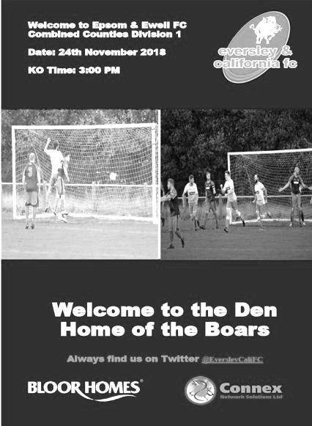
Low key performance leads to defeat

A trip to Fox Lane represented our longest journey of the season and whilst it may well turn out to be a nice venue to visit in future years, it currently has an unfinished and uninspiring look. Maybe this was partly why we failed to impose ourselves on our hosts and failed to create a great amount all day, whilst conceding twice to drop crucial league points, although credit should be given to the opposition who chased everything down and denied us space throughout the match.

We had a bit of a reshuffle at the back as Jamie Watts and Luke Elgar both unavailable so Sam Morgan came in and Adam Heagney dropped into the left back slot, moving Lloyd Connelly back into a central position after playing on the left against Dorkinians, while Bobby Bennett and Elliott Thompson returned to the starting line-up in place of the late arriving Olly Martinez who was on the bench.

Recently we have started very slowly in matches and it was something that our Management team have identified as an issue. However, we saw a similar pattern here as a near post strike from Aaron Rowland as early as the third minute came back off the frame of our goal before the hosts then took the lead in the 11th minute with a cleverly worked overlapping full back run on the left and a low cross in that was met by a side footed volley past Conor Young from about eight yards out from Brad Brown.

We responded with a deep cross from Liam Roberts which Rob Hendry jumped for, but he was beyond the far post at point of contact and did well to even get his header against the side of the post and out for a goal kick. Young was in action soon after to block a low shot after Eversley broke through on goal but Hendry was the next to have a chance with a snapshot that just cleared the bar from the edge of the box.

The hosts sent a dangerous free kick across the face of our goal, but it came to nothing and within seconds we were level. With the clock showing the 29th minute, Heagney started a good run forward from the left back position. He played the ball forward to

Roberts who clipped the ball forward to Hendry on the left and he squared the ball back in where Heagney had continued his run and he buried the shot low past the keeper from eight yards out.

We were looking a bit better at this point and a deep Morgan cross was clawed away by the keeper just ahead of the incoming Hendry but we were still vulnerable to the Eversley attacks and Young had to make two more good saves before the half was out. In truth we were fortunate to be level as the teams made the long trek back to the changing rooms at half time.

Going up the hill has worked well for us in recent times, most notably at Chessington & Hook United and I felt that we would improve on our first half performance to go on and win the match, but we were still struggling to break through, largely in my opinion because our build up play was too slow and so the opposition had plenty of time to organise themselves, which led to us passing the ball sideways without a major threat to the opposition. Even the crossfield ball that worked so well against Dorkinians was rarely tried as we struggled to make space.

Then things got worse when a shot from distance by Mo Davies in the 54th minute came back off the face of our crossbar, but we didn't react quickly enough to the second ball and Brown was there again to force it in from close range to restore their lead.

This was serious. Although we tried to press forward in search of an equaliser, our passing let us down and we were unable to get around the back of their defence often enough to cause them concern. We had two half chances as the game concluded when substitute Germaine Jeannoel hit a strong shot that deflected wide for a corner and in injury time a cross from Scott Murphy went to the near post, but Jeannoel's contact was not powerful enough and although the effort was on target it was an easy save in the end.

We could look at this result and say that it has probably ended any title chances and therefore our hopes of promotion this season, coupled with the dropped points last week against Kensington Borough and the removal of AC London which cost us another three points. However, that would be a bit harsh on our current team as this was our first defeat in seven matches. It has to be said though, that this performance really wasn't of the standard required and I'm sure that changes will be coming as a result.

Epsom and Ewell: Conor Young, Sam Morgan, Adam Heagney, Steve Betancourt,
Lloyd Connelly, Ryan Sullivan, Bobby Bennett, Scott Murphy (c), Rob Hendry,
Elliott Thompson, Liam Roberts

Subs: Scott Elgar for Thompson (63), Olly Martinez for Morgan (67),
Germaine Jeannoel for Betancourt (77)

This Day in History - 1st December
Date | Day | Competition |  | Opponents |  | Scorers
01/12/28 | Sat | Friendly | H | Tottenham Reserves | 0-7
01/12/34 | Sat | Friendly | H | Woking | 2-4 | J.Levison, M.Wiggins
01/12/45 | Sat | Friendly | A | Golders Green | 0-7
01/12/51 | Sat | Corinthian League | A | Maidstone United | 0-2
01/12/56 | Sat | Amateur Cup 4q rep | H | Sheppey United | 2-3 | J.Bangs, o.g.
01/12/62 | Sat | Corinthian League | H | Dorking | 1-1 | B.Lambert
01/12/73 | Sat | Surrey Senior League | H | Malden Town | 1-1 | T.Tuite
01/12/79 | Sat | Surrey Senior Cup 4q | A | Dorking Town | 1-3 | D.Walker
01/12/81 | Tue | Isthmian League 1 | H | Met Police | 0-1
01/12/84 | Sat | Isthmian League Premier Division | H | Windsor & Eton | 4-4 | T.Tuite (2), S.Milton, S.Hill
01/12/87 | Tue | London Senior Cup 3q | A | Thames Polytechnic | 3-0 | B.Perkins (3)
01/12/90 | Sat | Isthmian League 2s | H | Abingdon Town | 0-1
01/12/07 | Sat | Combined Counties Premier Division | A | Cobham | 2-3 | D.Smith, R.Burns
01/12/12 | Sat | Combined Counties Premier Division | H | Farnham Town | 3-1 | D.Marvell (2), K.Hough
Historical Decades
Date | Day | Competition |  | Opponents |  | Scorers
90 years ago – Epsom Town F.C.
01/12/28 | Sat | Friendly | H | Tottenham Reserves | 0-7
80 years ago – Epsom F.C.
26/11/38 | Sat | London League | A | R.N.Depot | 4-1 | R.Forbes, A.Curtis, B.Solly, J.Jones
70 years ago – Epsom F.C.
27/11/48 | Sat | Surrey Senior Cup 2q | H | Byfleet | 6-1 | T.Goodall, N.Griffiths (2, 1 pen), K.Minter, E.Watkins, F.Chitty
60 years ago – Epsom F.C.
29/11/58 | Sat | Corinthian League | A | Uxbridge | 2-4 | T.Millard, R.Brunwin
50 years ago – Epsom & Ewell F.C.
30/11/68 | Sat | Athenian League  Division 2 Cup 2 | H | Horsham | 0-2
40 years ago – Epsom & Ewell F.C.
02/12/78 | Sat | Surrey Senior Cup 4q | H | Bae Weybridge | 3-1 | S.Delaney, D.Walker, T.McCready
30 years ago – Epsom & Ewell F.C.
26/11/88 | Sat | F.A. Vase 2 | H | Three Bridges | 6-2+ | N.Robson (2), P.Andrews, B.Perkins, C.Walcott, C.Holding
20 years ago – Epsom & Ewell F.C.
28/11/98 | Sat | F.A. Vase 2 | A | Fakenham Town | 1-2 | J.Tome
10 years ago – Epsom & Ewell F.C.
06/12/08 | Sat | Combined Counties Premier Division | H | Horley Town | 0-0

History Corner – 1st December
90 years ago today we welcomed a Tottenham Hotspur Reserve eleven to West Street for a friendly Challenge match. They brought down a strong side, containing five players with first team experience; Bellamy, Handley, Brown, Smith and Cable and had far too much for us on the day, winning 7-0. In fact they enjoyed their day out so much they said they’d return later in the season, which they did for an Easter Saturday fixture later that season, winning 6-3 on that occasion with Handley again playing and being involved in all six of their goals!

73 years ago today we visited Claremont Road for a friendly Challenge match with Golders Green who would a few years later change their name to Hendon. However, they were fairly strong already by this time and defeated us there by seven clear goals as we fell away in the second half after trailing by just one at the break. In their side that day was a player by the name of Pat Lynch who would join us as Player / Coach in the summer of 1952.

62 years ago today we departed the Amateur Cup at the Final Qualifying Round stage by three goals to two at home to Kent League Sheppey United. We had secured a good 0-0 draw there a week previously but an entertaining replay ended on a sour note when Ernie Watkins appeared to equalise, only for the referee, who came from Kent, to announce that the game had finished. According to the local paper report he blew for full time two minutes and ten seconds before the end of the match but a protest got us nowhere. Had we have gone on to win in extra time or a further replay, it would have been our first appearance in the First Round Proper since 1935 but it wasn’t to be and indeed we would never reach that promised land again.

31 years ago today Brian Perkins scored his first hat trick for the club in an away London Senior Cup tie with Thames Polytechnic which had been switched to West Street. All his goals came in the first half as we won 3-0.

30 years ago this week we were at home to Three Bridges in our first F.A. Vase campaign for eleven seasons. We had defeated Chatham Town and then scraped past Banstead Athletic after extra time but things didn’t look too healthy as we trailed by a goal. However, an Epsom equaliser in the final twenty minutes forced a bizarre period of extra time, still the most incredible in the club’s history; containing six goals and we got five of them to win 6-2!!

6 years ago today we trailed at half time at home to Farnham Town but recovered to win 3-1 with a flying header from Dale Marvell being the highlight. This is one of my favourite pictures by Gemma Jarman and I make no apology for showing it once again here!

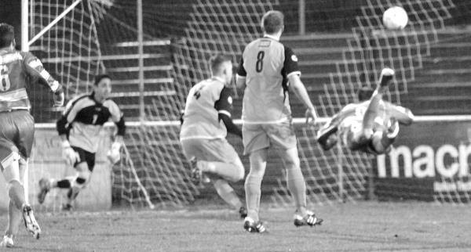

Centre page for results

Centre page for results

EL Records Premier Challenge Cup
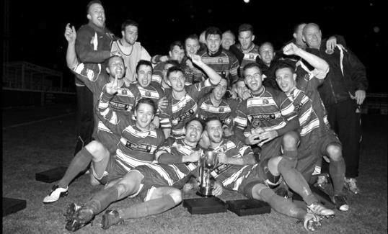
First Round
Camberley Town | 1-3 | Cobham
Horley Town | 0-1 | Chertsey Town
Badshot Lea | 3-1 | Walton & Hersham
FC Deportivo Galicia | 4-1 | Cove
Chessington & Hook United | 2-4 | AFC Hayes
Farnham Town | 1-2 | Southall
Hanworth Villa | 3-1 | Kensington Borough
Second Round
Bedfont & Feltham | 2-0 | Tooting Bec
Sheerwater | 1-0 | Balham
Ash United | 2-3 | Fleet Spurs
Frimley Green | 0-2 | Guildford City
Godalming Town | 2-0 | Dorking Wanderers Reserves
Abbey Rangers | 3-0 | Redhill
FC Deportivo Galicia | 5-0 | AC London
Cobham | 0-3 | AFC Hayes
Abandoned after 88 minutes due to serious player injury - Match awarded to AFC Hayes
CB Hounslow United | 4-1 | Badshot Lea
Hanworth Villa | 2-1 | Sandhurst Town
Epsom & Ewell | 1-0 | Bagshot
Sutton Common Rovers | 4-2 | Southall
Chertsey Town | 3-2 | British Airways
Eversley & California | 1-5 | Knaphill
Banstead Athletic | 4-3 | Colliers Wood United
Spelthorne Sports | 2-1 | Raynes Park Vale
Third Round
FC Deportivo Galicia | V | Sutton Common Rovers
AFC Hayes | V | Bedfont & Feltham
Epsom & Ewell | V | Godalming Town
Sheerwater | V | Banstead Athletic
Guildford City | V | CB Hounslow United
Spelthorne Sports | V | Hanworth Villa
Knaphill | V | Fleet Spurs
Chertsey Town | V | Abbey Rangers

Godalming Town – History
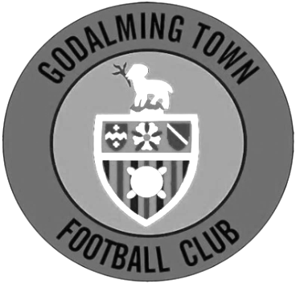
The club has its origins as Godalming United FC, formed in 1950 by ex-pupils of Godalming Grammar School.

Between 1950-71 the club played at the Recreation Ground. However, in 1970 Surrey Senior League side Farncombe collapsed, leaving their ground in Meadrow vacant. Godalming took over the debts and tenancy, changing their name to Godalming and Farncombe FC, and the ground to Wey Court in the process.

The original pitch was where the nearby Wey Court Sheltered Housing stood and considerable amount of work was undertaken on the new playing area, which was built on the site of an old waste tip. The club was helped by Waverley Council when drainage problems and subsidence meant they had to find a temporary home at Broadwater Park.

The club was accepted into the Combined Counties League for the start of the 1978 season, and a year later the name was changed again, to Godalming Town FC.

In 1985, another local club, Addlestone & Weybridge, was disbanded and, before their ground at Liberty Lane was demolished, Godalming purchased the stand and perimeter fence for £225 and £50 respectively. The stand was re-erected at Wey Court, with seating and fascia added.

The next development came in 1992 when the Guildford Football Appeal (formed in an attempt to return the towns name to senior football, following the collapse of Guildford City in 1977) donated a sum of money towards floodlights, and in return the name of the club was changed again to Godalming & Guildford FC.

Further recycling followed in 1995, when a new turnstile building was erected incorporating a turnstile from Millwall’s old ground and in 1996 the clubhouse was refurbished.

During 2005 close season, the club changed its name for a fifth time, albeit back to one of its previous incarnations, that of Godalming Town. A fantastic 2005/06 season saw the side take the Combined Counties League Championship and League Cup by storm. Godalming Town were then accepted by Isthmian League officials following extensive ground improvements.

At the end of a tough season, Godalming found themselves at the bottom of a very competitive division. However, events elsewhere meant that Godalming were reprieved from relegation and were transferred into the Southern League’s South & West Division for the 2007/08 season. Chuck Martini replaced Roger Steer as Manager in October 2007. Town were moved back to the Ryman League for the 2008/09 season and eventually finished in another record high position, 9th. Godalming also progressed further than ever before in the FA Cup by reaching the 3rd Qualifying Round before losing 2-1 at Conference South side Havant & Waterlooville.

The 2009/10 season was arguably the best season in the history of the club. Town finished a record high position 4th in the Ryman South but were eventually beaten 2-1 in the Playoff Final at Folkestone Invicta. The club progressed further than ever before in the FA Trophy and won the Surrey Senior Cup by beating Sutton United 2-1. The season also saw local boy Shaun Elliott became the club’s record appearance holder after reaching 360 games in a

Godalming shirt. Chuck Martini was replaced by joint-managers Jon Underwood & Neil Baker in October 2010 and the club finished an unpredictable season in mid-table. The 2011/12 season saw a lot of new faces join, but the team quickly gelled, reaching the 4th Qualifying Round of the FA Cup, beating Wimborne, Moneyfields, Worcester City & Bodmin before bowing out to Maidenhead United in front of 700 at Wey Court. The G’s finished 5th in the league, and travelled to Bognor Regis Town in the playoff semi-final, drawing 4-4 after extra time but Godalming lost 5-3 on penalties.

2012/13 saw Jon Underwood and Neil Baker guide Godalming to their highest ever finish in the pyramid, finishing in 3rd place. The G’s lost in the playoff semi-final for the second year running, this time losing 2-1 to Biggleswade at Wey Court. The season finished on a high however, as Godalming lifted the Surrey Senior Cup for the second time in four years, beating Sutton United 1-0 at Gander Green Lane, thanks to a last minute goal from Scott Harris. The close season saw Godalming moved to a third different league in as many years, this time to the South & West Division. With divisional change came a managerial change; Jon Underwood and Neil Baker left Godalming to join Slough Town, taking the majority of the squad with them. Andy Hunt was appointed manager in June 2013, assisted by Neil Selby.

The 2013/14 season was probably one of the hardest the club has dealt with. Andy Hunt was given the task of putting together a squad that will compete in the league and secure step four football. At Christmas 2013 the clubhouse, kitchen and changing rooms were ruined by flood water. Godalming finished the season in 18th position. Godalming were then moved into another division again and will play in Southern League Central Division for the 2014/15 season.

Godalming finished in 10th position in the 2015/2016 and reached the Surrey Senior Cup Final for the 3rd time but lost 4-0 to Merstham.

The 2016/2017 season could be viewed as an annus horibilis for the men as wins became less frequent than management changes. Andy Hunt left and was replaced by Dean Thomas who subsequently departed before the club was relegated under Dan Turkington. Inevitably relegation followed and Dan departed, as did much of the entire first team.

On the upside the Ladies team under the auspices of Steve Davies and , Darren Wheeler finished second in Division 2 South and were promoted to division one in the Greater London Womens Football League.

2017/18 began in familiar fashion with a new management and a new squad in a new division. After a promising start under Simon Funnell and Matt Drew (including a brief run in the FA Cup which finally ended at Hereford), wins became harder to come by and by Christmas, Jon Palmer and Gavin Smith were in charge. After a slow start, a promising run took the G’s out of the relegation zone before fixture congestion and a high turnover of players led to a second relegation in two years.

The Ladies first team continued to go from strength to strength with an exciting FA Cup run and promotion to the GLWFL Premiership. The Ladies development team finished an excellent 3rd in division 3 which meant they were promoted also in the division two south for the 2018/19 season.

Godalming Town first team will compete in the Combined Counties League Division One for the 2018/19 season.

Player Sponsorship
Here is the latest list for 2018/19, with new photos showing all of our players and Management that are available for sponsorship.

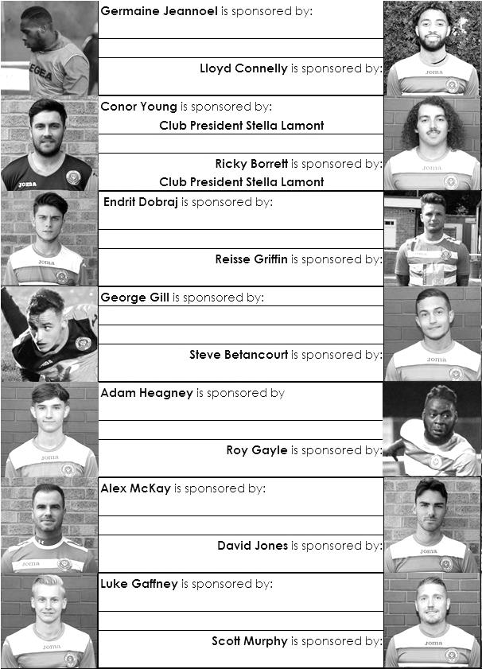

Sponsorship costs just £40 and it is easy to do. Just select a player who has not been previously sponsored and let a Committee Member know that you would like to sponsor them. Beware though. Until we have received the money it is possible for someone to jump in front of you, so don’t delay, sponsor today!
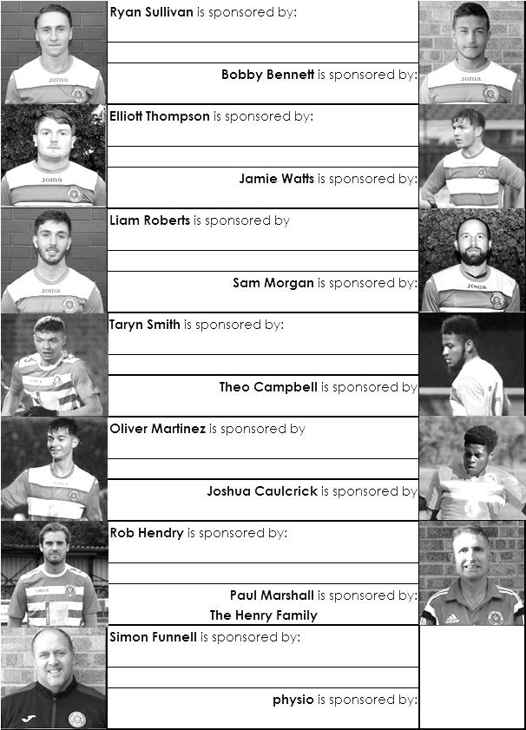

Match and Ball Sponsorships – 2018/19
Opponent | Date | Match Sponsor | Ball Sponsor
Chessington & Hook Utd | 21/08/18 | Club President - Stella Lamont
Beckenham Town (FAC) | 28/08/18 | Building Shop Ltd
Cove | 08/09/18 | EEFC Management Committee
Tooting Bec | 15/09/18 | Building Shop Ltd
Bagshot (LC) | 25/09/18
Sheerwater | 06/10/18 | Paul Merritt
Knaphill U23  (Surrey Premier Cup) | 23/10/18 | Jack Jarman
Frimley Green | 03/11/18 | Our Chairman’s Grandchildren – George, Joseph, Ezara and Inaya
Sandhurst Town (LD1C) | 06/11/18 | Richard Lambert
Kensington Borough | 17/11/18 | Jeff & Arnold Pye
Dorkinian (SPC) | 20/11/18
Dorking Wanderers Res | 27/11/18
Godalming Town | 01/12/18 | John Bonner
Bedfont & Feltham | 08/12/18
Eversley & California | 29/12/18
Ash United | 12/01/19
Bagshot | 19/01/19
Farnham Town | 02/02/19
British Airways | 16/02/19
AC London | 02/03/19
FC Deportivo Galicia | 12/03/19
Fleet Spurs | 06/04/19
Sandhurst Town | 20/04/19 | Club President - Stella Lamont
Godalming Town (LC) |  | Date unknown
Unknown (SPC) |  | 3rd Round – might be at home
Match sponsorship costs just £60.00!

Sponsorship includes:

Admission, programmes and hospitality for three people.

A full page advert in the programme and mascot for the day (if required).

If you are interested, just speak to a Committee Member,
or drop me an email at: richard.c.lambert@gmail.com

Combined Counties League Premier Division
Opponents All-time Records
incl Saturday  24th November | P | W | D | L | F | A | PPG | GD | Best  Win | Worst  Loss
Bedfont & Feltham | 2 | 2 | 0 | 0 | 13 | 3 | 3.00 | +10 | 9-2 | -
AC London | 1 | 1 | 0 | 0 | 6 | 0 | 3.00 | +6 | 6-0 | -
Bagshot | 2 | 2 | 0 | 0 | 4 | 0 | 3.00 | +4 | 3-0 | -
FC Deportivo Galicia | 1 | 1 | 0 | 0 | 3 | 0 | 3.00 | +3 | 3-0 | -
Tooting Bec | 1 | 1 | 0 | 0 | 3 | 1 | 3.00 | +2 | 3-1 | -
Fleet Spurs | 1 | 1 | 0 | 0 | 3 | 2 | 3.00 | +1 | 3-2 | -
Frimley Green | 11 | 9 | 1 | 1 | 35 | 5 | 2.55 | +30 | 7-1 | 0-1
Godalming Town | 3 | 2 | 0 | 1 | 4 | 5 | 2.00 | -1 | 2-1 | 0-3
Ash United | 20 | 11 | 3 | 6 | 50 | 32 | 1.80 | +18 | 6-0 | 0-3
Farnham Town | 18 | 9 | 4 | 5 | 31 | 29 | 1.72 | +2 | 3-0 | 1-4
Cove | 35 | 16 | 9 | 10 | 78 | 57 | 1.63 | +21 | 7-0 | 1-6
Chessington & Hook | 30 | 13 | 9 | 8 | 63 | 45 | 1.60 | +18 | 6-0 | 1-3
Sheerwater | 5 | 2 | 2 | 1 | 10 | 5 | 1.60 | +5 | 3-0 | 2-3
Dorking Wanderers Res | 2 | 1 | 0 | 1 | 6 | 5 | 1.50 | +1 | 3-0 | 3-5
Sandhurst Town | 16 | 7 | 0 | 9 | 28 | 28 | 1.31 | 0 | 4-0 | 1-3
Kensington Borough | 1 | 0 | 1 | 0 | 1 | 1 | 1.00 | 0 | - | -
British Airways | 1 | 0 | 0 | 1 | 2 | 3 | 0.00 | -1 | - | 2-3
Eversley & California | 1 | 0 | 0 | 1 | 1 | 2 | 0.00 | -1 | - | 1-2
Ken Huckle – Combined Counties League President

Sadly the League has lost another of his stalwarts earlier this week, with the sad news that League President Ken Huckle has died.

Ken has been associated with the Combined Counties League for many years and will largely be remembered as the League's Referees' Secretary and of course, as a respected referee himself in his younger days, officiating at higher levels.

Ken succeeded Ron Monkley as the League's President several seasons ago and has been very active in the role, taking a full part in the League's business and frequently undertaking ground inspections. He was always vocal when it came to business affecting match officials and his dedication to this League could not be questioned.

There are no funeral details as yet but we send our deepest sympathies to Judi, Ken's wife who has looked after him in recent days following his release from hospital and to all members of his family, including his mother who is still alive despite her 100 years plus.

I will announce more details once I have them.

Alan Constable
Director and General/Fixture Secretary, Combined Counties Football League Ltd

Combined Counties League – Division One
Saturday, 1st December 2018 - Kick-off 3.00 p.m.
Epsom and Ewell  (Royal Blue & White hoops) | V |  | Godalming Town  (Yellow / Green / Yellow )
Squad | NUMBERS |  | Squad
Conor Young |  |  | Jordan Knight
Ricky Borrett |  |  | Taylor Davies
Luke Elgar |  |  | Jordan Bird ©
Reisse Griffin |  |  | Jack Howard
Lloyd Connelly |  |  | Curtis Osano
Jamie Watts |  |  | Levi Crew
Steve Betancourt |  |  | Craig Adu-Adeji
David Jones |  |  | Chris Burke
Adam Heagney |  |  | Ashley Wright
Todd Murphy |  |  | Darren Wheeler
Ryan Sullivan |  |  | Jack Cleevely
Liam Roberts |  |  | Dom Hardisty
© Scott Murphy |  |  | Abdullah Asiamah
Scott Elgar |  |  | Frankie Ryan-Maynard
Elliott Thompson |  |  | Anthony Myers
Bobby Bennett
Rob Hendry
Roy Gayle
Olly Martinez
Germaine Jeannoel
Joshua Caulcrick
Taryn Smith
Simon Funnell | MANAGER |  | Les Cleevely
Matt Drew | ASST MANAGER |  | Jordan Knight
Sam Morgan | COACHES |  | Jason Kerbey
 | PHYSIO |  | Rebecca Peacock
REFEREE: N.Keirs
ASSISTANTS: B.Smith, J.Healy
Today’s match is sponsored by
regular supporter and occasional Linesman John Bonner!

OUR NEXT VISITORS TO HIGH ROAD
Bedfont & Feltham
Combined Counties League – Division One
Saturday, 8th December 2018 – 3.00 pm

